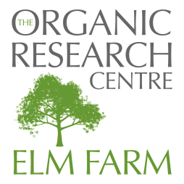
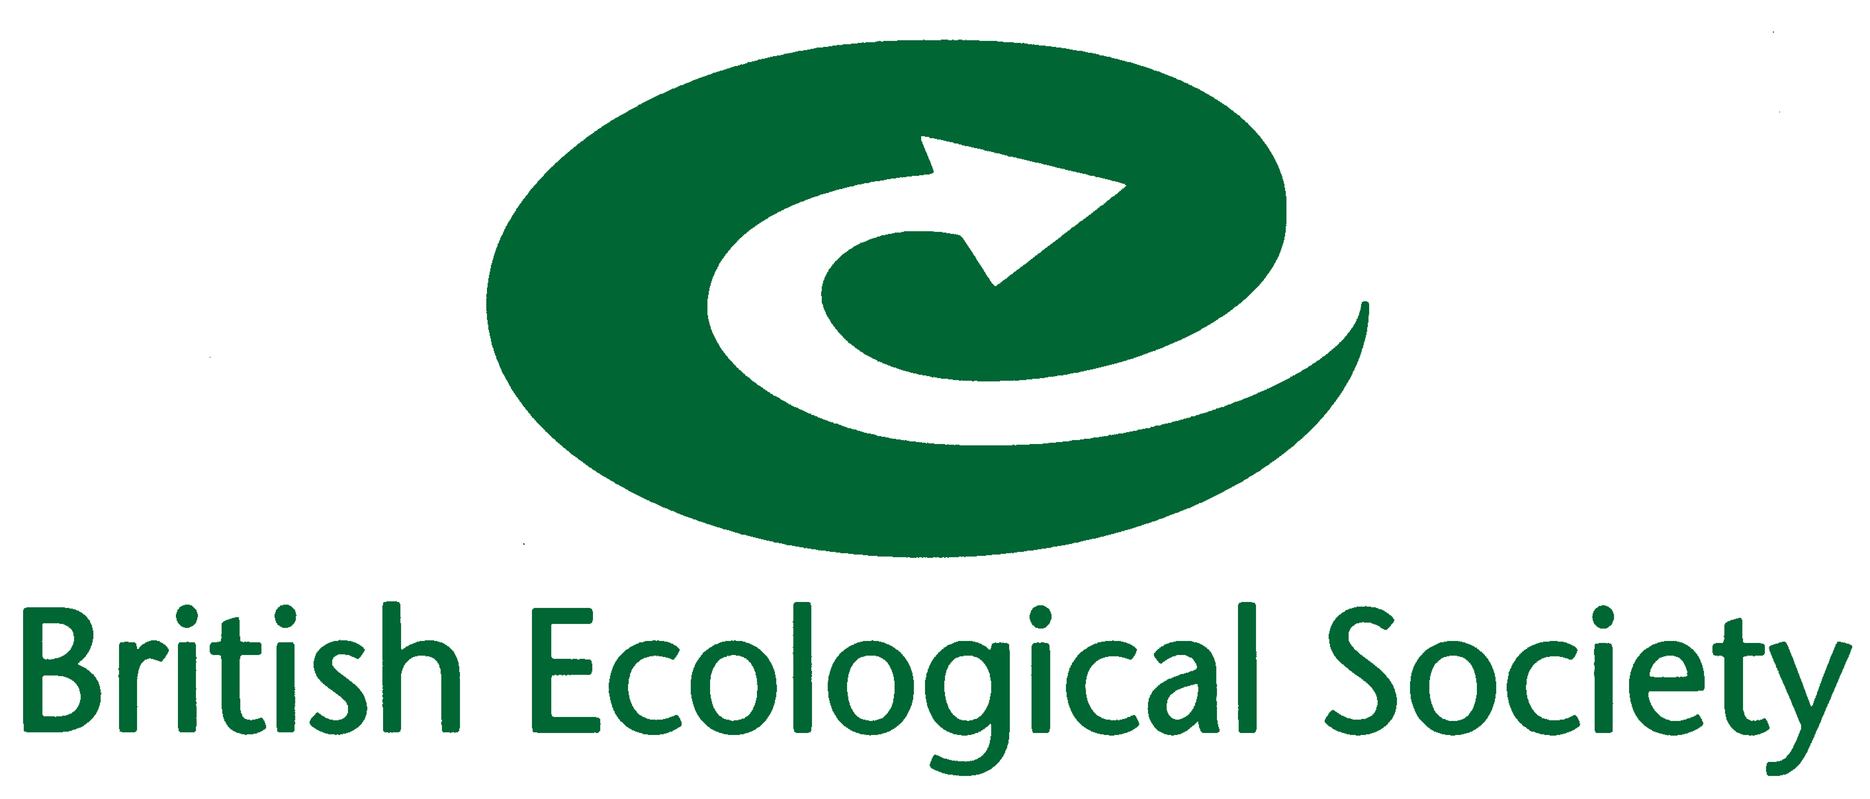
The role and potential of organic farming
in delivering functional biodiversity
and ecosystem services
Agricultural Ecology Group
Tuesday 17th May
Organic Research Centre, Elm Farm
Hamstead Marshall, Newbury,
Berkshire RG20 0HR

REGISTRATION FORM
DEADLINE FOR REGISTRATION 12TH MAY

PARTICIPANT DETAILS: Please complete a separate form for EACH participant attending:

Title: | First Name: | Last Name:
Organisation:
Details for Name Badge:
Address:
 |  |  | Postcode:
Email:
Telephone:

Special dietary requirements Vegetarian  Vegan  Other 

Any other special requirements (i.e. wheelchair access, etc)  (please give details):

Registration Fee £25

Payment details:

I enclose a cheque for £ | made payable to Progressive Farming Trust Ltd
or debit my Mastercard/Visa/Maestro:
Name of Cardholder:
Card No: |  | Expiry Date:
Start Date of Card (Maestro only): |  | Issue No (Maestro only):
Security No (last 3 digits on signature strip on back of card):

If you would like to submit this form by e-mail, but prefer not to e-mail your credit card details, please e-mail the form and then telephone Gillian Woodward on 01488 658279.

Post, e-mail or fax this form to:

The Organic Research Centre, Elm Farm, Hamstead Marshall, Newbury, Berkshire, RG20 0HR.

E-mail: gillian.w@organicresearchcentre.com

Fax: 01488 658503

Telephone: 01488 658279

